PROJECT NAME: **Quiz**

Assigned by Sir Hafeez

Completed by:

Imran Roshan 🡪 K-20SW013

Zahoor Ahmed 🡪 K20SW002

Objective/ Vision

It provides a common platform to connect student and teacher online. The registered teacher can create Quiz and student can take quiz and can assess himself/herself.

Users of the System

1. Teacher
2. Student

Functional Requirements

**1. Teacher**

1. Can create quiz after getting logged in!
2. Can enter subjects and enter question with its options and answer at the time of creating quiz.
3. 10 Question for each quiz required to be completed.

**2. Student**

1. Can search quiz according to their interest.
2. Click on the id of quiz and ready to start it just clicking on a button.
3. After completing all questions, result will be displayed Automatically.
4. Can view the description about every question in the respective quiz.

User Interface Priorities

1. Professional look and feel

Tools to be used

1. Use any IDE to develop the project. It may be Myeclipse / Eclipse / Netbeanse.

How project works?

First step:-

Simple minds page will be opened.

Login in it and go to the rules .

2 buttons in the front page Rules and exit

When you to login in it and click on rules the rules will be opened

When you click on the exist the quiz will be closed.

Second step:

Rules will be opened for the test

2 Buttons on this page back and start.

After reading the rules you have to options back and start

When you click on back it will go to the previous page

When you click on the start the quiz will be started.

Third step:

Questions will be displayed, and three buttons are there:

1. Next🡪 when you click on the next the question will be moved to next.
2. 50-50Lifeline🡪When you click on this it will increase the timing of the timer.
3. Submit🡪 it is unable to use it will be used at the last mcqs.

Timer 🡪 it if for the time limit of the mcqs. When you do not click on the next it will be automatic changed

*In last the result will be shown automatically:*

Software Requirement to run this project

1. You need to install an IDE Eclipse / MyEclipse / NetBeans.

Hot to run this project

Import the project on the IDE and run it. All the tables will be created automatically.

Docs:

Simple minds:

Code:

**package** simple.minds;  
**import** javax.swing.*;  
**import** java.awt.*;  
**import** java.awt.event.*;  
**public class** SimpleMinds **extends** JFrame **implements** ActionListener{  
 JButton **b1**, **b2**;  
 JTextField **t1**;  
 SimpleMinds(){  
 setBounds(0, 0, 1200, 500); *// dleft, //dup // length, height ///////* getContentPane().setBackground(Color.***WHITE***);  
 setLayout(**null**);  
  
 ImageIcon i1 = **new** ImageIcon(ClassLoader.*getSystemResource*(**"simple/minds/login.jpeg"**));  
 JLabel l1 = **new** JLabel(i1);  
 l1.setBounds(0, 0, 600, 500);  
 add(l1);  
  
 JLabel l2 = **new** JLabel(**"Simple Minds"**);  
 l2.setFont(**new** Font(**"Viner Hand ITC"**, Font.***BOLD***, 40));  
 l2.setForeground(**new** Color(30, 144, 254));  
 l2.setBounds(750, 60, 300, 45);  
 add(l2);  
  
 JLabel l3 = **new** JLabel(**"Enter Your Name"**);  
 l3.setFont(**new** Font(**"Mongolian Baiti"**, Font.***BOLD***, 18));  
 l3.setForeground(**new** Color(30, 144, 254));  
 l3.setBounds(810, 150, 300, 20);  
 add(l3);  
  
 **t1** = **new** JTextField();  
 **t1**.setBounds(735, 200, 300, 25);  
 **t1**.setFont(**new** Font(**"Times New Roman"**, Font.***BOLD***, 20));  
 add(**t1**);  
  
 **b1** = **new** JButton(**"Rules"**);  
 **b1**.setBounds(735, 270, 120, 25);  
 **b1**.setBackground(**new** Color(30, 144, 254));  
 **b1**.setForeground(Color.***WHITE***);  
 **b1**.addActionListener(**this**);  
 add(**b1**);  
  
 **b2** = **new** JButton(**"Exit"**);  
 **b2**.setBounds(915, 270, 120, 25);  
 **b2**.setBackground(**new** Color(30, 144, 254));  
 **b2**.setForeground(Color.***WHITE***);  
 **b2**.addActionListener(**this**);  
 add(**b2**);  
  
 setVisible(**true**);  
 }  
  
 **public void** actionPerformed(ActionEvent ae){  
 **if**(ae.getSource() == **b1**){  
 String name = **t1**.getText();  
 **this**.setVisible(**false**);  
 **new** Rules(name);  
 }**else**{  
 System.*exit*(0);  
 }  
 }  
  
 **public static void** main(String[] args) {  
 **new** SimpleMinds();  
 }  
}

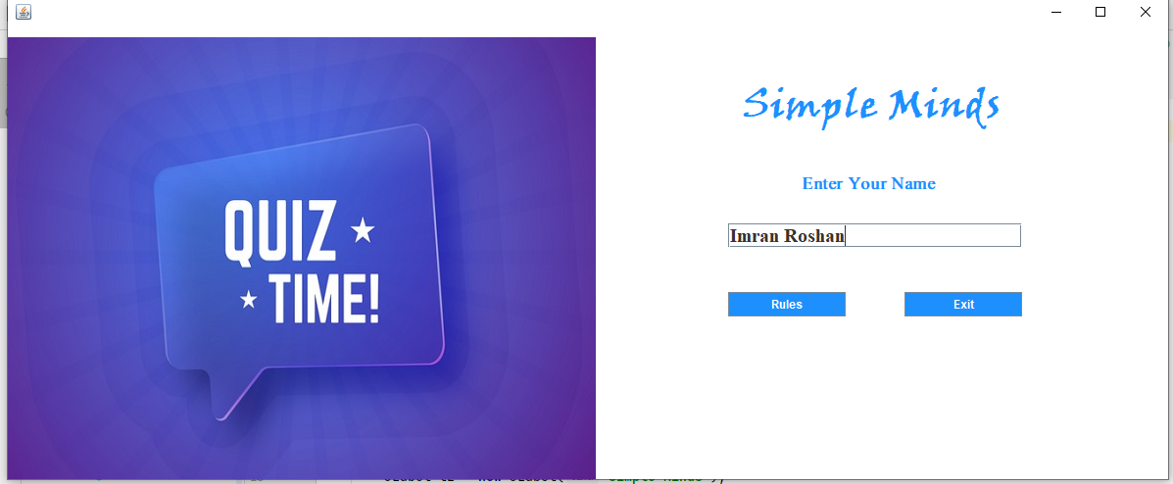

Rules:

**package** simple.minds;

**import** javax.swing.*;

**import** java.awt.*;

**import** java.awt.event.*;

**public class** Rules **extends** JFrame **implements** ActionListener{

JButton **b1**, **b2**;

String **username**;

Rules(String username){

**this**.**username** = username;

setBounds(0, 0, 800, 650);

getContentPane().setBackground(Color.***WHITE***);

setLayout(**null**);

JLabel l1 = **new** JLabel(**"Welcome "** + username + **" to Simple Minds"**);

l1.setForeground(**new** Color(30, 144, 255));

l1.setFont(**new** Font(**"Viner Hand ITC"**, Font.***BOLD***, 28));

l1.setBounds(50, 20, 700, 30);

add(l1);

JLabel l2 = **new** JLabel(**""**);

l2.setFont(**new** Font(**"Tahoma"**, Font.***PLAIN***, 16));

l2.setBounds(20, 90, 600, 350);

l2.setText(

**"<html>"**+

**"1. You are trained to be a programmer and not a story teller, answer point to point"** + **"<br><br>"** +

**"2. Do not unnecessarily smile at the person sitting next to you, they may also not know the answer"** + **"<br><br>"** +

**"3. You may have lot of options in life but here all the questions are compulsory"** + **"<br><br>"** +

**"4. Crying is allowed but please do so quietly."** + **"<br><br>"** +

**"5. Only a fool asks and a wise answers (Be wise, not otherwise)"** + **"<br><br>"** +

**"6. Do not get nervous if your friend is answering more questions, may be he/she is doing Jai Mata Di"** + **"<br><br>"** +

**"7. Brace yourself, this paper is not for the faint hearted"** + **"<br><br>"** +

**"8. May you know more than what John Snow knows, Good Luck"** + **"<br><br>"** +

**"<html>"**

);

add(l2);

**b1** = **new** JButton(**"Back"**);

**b1**.setBounds(250, 500, 100, 30);

**b1**.setBackground(**new** Color(30, 144, 255));

**b1**.setForeground(Color.***WHITE***);

**b1**.addActionListener(**this**);

add(**b1**);

**b2** = **new** JButton(**"Start"**);

**b2**.setBounds(400, 500, 100, 30);

**b2**.setBackground(**new** Color(30, 144, 255));

**b2**.setForeground(Color.***WHITE***);

**b2**.addActionListener(**this**);

add(**b2**);

setVisible(**true**);

}

**public void** actionPerformed(ActionEvent ae){

**if**(ae.getSource() == **b1**){

**this**.setVisible(**false**);

**new** SimpleMinds().setVisible(**true**);

}**else if**(ae.getSource() == **b2**){

**this**.setVisible(**false**);

**new** Quiz(**username**).setVisible(**true**);

}

}

**public static void** main(String[] args){

**new** Rules(**""**);

}

}

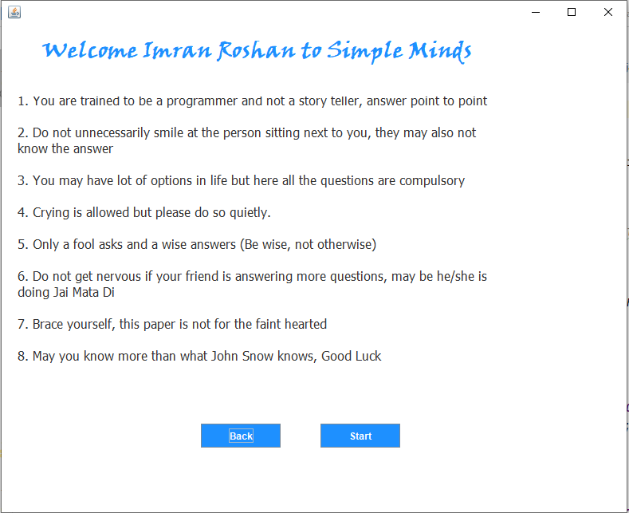

Quiz:

**package** simple.minds;

**import** javax.swing.*;

**import** java.awt.*;

**import** java.awt.event.*;

**public class** Quiz **extends** JFrame **implements** ActionListener{

JButton **next**, **submit**, **lifeline**;

**public static int** *count* = 0;

**public static int** *timer* = 15;

**public static int** *ans_given* = 0;

**public static int** *score* = 0;

JLabel **qno**, **question**;

String **q**[][] = **new** String[10][5];

String **pa**[][] = **new** String[10][1];

String **qa**[][] = **new** String[10][2];

JRadioButton **opt1**, **opt2**, **opt3**, **opt4**;

ButtonGroup **options**;

String **username**;

Quiz(String username){

**this**.**username** = username;

setBounds(0, 0, 1200, 700);

getContentPane().setBackground(Color.***WHITE***);

setLayout(**null**);

ImageIcon i1 = **new** ImageIcon(ClassLoader.*getSystemResource*(**"simple/minds/quiz.jpg"**));

JLabel l1 = **new** JLabel(i1);

l1.setBounds(0, 0, 1200, 300);

add(l1);

**qno** = **new** JLabel(**""**);

**qno**.setFont(**new** Font(**"Tahoma"**, Font.***PLAIN***, 24));

**qno**.setBounds(100, 450, 50, 30);

add(**qno**);

**question** = **new** JLabel(**""**);

**question**.setFont(**new** Font(**"Tahoma"**, Font.***PLAIN***, 24));

**question**.setBounds(150, 350, 800, 30);

add(**question**);

**q**[0][0] = **"Which is used to find and fix bugs in the Java programs.?"**;

**q**[0][1] = **"JVM"**;

**q**[0][2] = **"JDB"**;

**q**[0][3] = **"JDK"**;

**q**[0][4] = **"JRE"**;

**q**[1][0] = **"What is the return type of the hashCode() method in the Object class?"**;

**q**[1][1] = **"int"**;

**q**[1][2] = **"Object"**;

**q**[1][3] = **"long"**;

**q**[1][4] = **"void"**;

**q**[2][0] = **"Which package contains the Random class?"**;

**q**[2][1] = **"java.util package"**;

**q**[2][2] = **"java.lang package"**;

**q**[2][3] = **"java.awt package"**;

**q**[2][4] = **"java.io package"**;

**q**[3][0] = **"An interface with no fields or methods is known as?"**;

**q**[3][1] = **"Runnable Interface"**;

**q**[3][2] = **"Abstract Interface"**;

**q**[3][3] = **"Marker Interface"**;

**q**[3][4] = **"CharSequence Interface"**;

**q**[4][0] = **"In which memory a String is stored, when we create a string using new operator?"**;

**q**[4][1] = **"Stack"**;

**q**[4][2] = **"String memory"**;

**q**[4][3] = **"Random storage space"**;

**q**[4][4] = **"Heap memory"**;

**q**[5][0] = **"Which of the following is a marker interface?"**;

**q**[5][1] = **"Runnable interface"**;

**q**[5][2] = **"Remote interface"**;

**q**[5][3] = **"Readable interface"**;

**q**[5][4] = **"Result interface"**;

**q**[6][0] = **"Which keyword is used for accessing the features of a package?"**;

**q**[6][1] = **"import"**;

**q**[6][2] = **"package"**;

**q**[6][3] = **"extends"**;

**q**[6][4] = **"export"**;

**q**[7][0] = **"In java, jar stands for?"**;

**q**[7][1] = **"Java Archive Runner"**;

**q**[7][2] = **"Java Archive"**;

**q**[7][3] = **"Java Application Resource"**;

**q**[7][4] = **"Java Application Runner"**;

**q**[8][0] = **"Which of the following is a mutable class in java?"**;

**q**[8][1] = **"java.lang.StringBuilder"**;

**q**[8][2] = **"java.lang.Short"**;

**q**[8][3] = **"java.lang.Byte"**;

**q**[8][4] = **"java.lang.String"**;

**q**[9][0] = **"Which of the following option leads to the portability and security of Java?"**;

**q**[9][1] = **"Bytecode is executed by JVM"**;

**q**[9][2] = **"The applet makes the Java code secure and portable"**;

**q**[9][3] = **"Use of exception handling"**;

**q**[9][4] = **"Dynamic binding between objects"**;

**qa**[0][1] = **"JDB"**;

**qa**[1][1] = **"int"**;

**qa**[2][1] = **"java.util package"**;

**qa**[3][1] = **"Marker Interface"**;

**qa**[4][1] = **"Heap memory"**;

**qa**[5][1] = **"Remote interface"**;

**qa**[6][1] = **"import"**;

**qa**[7][1] = **"Java Archive"**;

**qa**[8][1] = **"java.lang.StringBuilder"**;

**qa**[9][1] = **"Bytecode is executed by JVM"**;

**opt1** = **new** JRadioButton(**""**);

**opt1**.setBounds(170, 400, 700, 30);

**opt1**.setFont(**new** Font(**"Dialog"**, Font.***PLAIN***, 20));

**opt1**.setBackground(Color.***WHITE***);

add(**opt1**);

**opt2** = **new** JRadioButton(**""**);

**opt2**.setBounds(170, 440, 700, 30);

**opt2**.setFont(**new** Font(**"Dialog"**, Font.***PLAIN***, 20));

**opt2**.setBackground(Color.***WHITE***);

add(**opt2**);

**opt3** = **new** JRadioButton(**""**);

**opt3**.setBounds(170, 480, 700, 30);

**opt3**.setFont(**new** Font(**"Dialog"**, Font.***PLAIN***, 20));

**opt3**.setBackground(Color.***WHITE***);

add(**opt3**);

**opt4** = **new** JRadioButton(**""**);

**opt4**.setBounds(170, 520, 700, 30);

**opt4**.setFont(**new** Font(**"Dialog"**, Font.***PLAIN***, 20));

**opt4**.setBackground(Color.***WHITE***);

add(**opt4**);

**options** = **new** ButtonGroup();

**options**.add(**opt1**);

**options**.add(**opt2**);

**options**.add(**opt3**);

**options**.add(**opt4**);

**next** = **new** JButton(**"Next"**);

**next**.setFont(**new** Font(**"Tahoma"**, Font.***PLAIN***, 22));

**next**.setBackground(**new** Color(30, 144, 255));

**next**.setForeground(Color.***WHITE***);

**next**.addActionListener(**this**);

**next**.setBounds(900, 450, 200, 40);

add(**next**);

**lifeline** = **new** JButton(**"50-50 Lifeline"**);

**lifeline**.setFont(**new** Font(**"Tahoma"**, Font.***PLAIN***, 22));

**lifeline**.setBackground(**new** Color(30, 144, 255));

**lifeline**.setForeground(Color.***WHITE***);

**lifeline**.setBounds(900, 500, 200, 40);

**lifeline**.addActionListener(**this**);

add(**lifeline**);

**submit** = **new** JButton(**"Submit"**);

**submit**.setFont(**new** Font(**"Tahoma"**, Font.***PLAIN***, 22));

**submit**.setEnabled(**false**);

**submit**.setBackground(**new** Color(30, 144, 255));

**submit**.setForeground(Color.***WHITE***);

**submit**.addActionListener(**this**);

**submit**.setBounds(900, 550, 200, 40);

add(**submit**);

start(0);

}

**public void** actionPerformed(ActionEvent ae){

**if**(ae.getSource() == **next**){

repaint();

**opt1**.setEnabled(**true**);

**opt2**.setEnabled(**true**);

**opt3**.setEnabled(**true**);

**opt4**.setEnabled(**true**);

*ans_given* = 1;

**if**(**options**.getSelection() == **null**){

**pa**[*count*][0] = **""**;

}**else** {

**pa**[*count*][0] = **options**.getSelection().getActionCommand();

}

**if**(*count* == 8){

**next**.setEnabled(**false**);

**submit**.setEnabled(**true**);

}

*count*++;

start(*count*);

}**else if**(ae.getSource() == **submit**){

*ans_given* = 1;

**if**(**options**.getSelection() == **null**){

**pa**[*count*][0] = **""**;

}**else** {

**pa**[*count*][0] = **options**.getSelection().getActionCommand();

}

**for**(**int** i =0 ; i < **pa**.**length** ; i++){

**if**(**pa**[i][0].equals(**qa**[i][1])){

*score*+=10;

}**else**{

*score*+=0;

}

}

**this**.setVisible(**false**);

**new** Score(**username**, *score*).setVisible(**true**);

}**else if**(ae.getSource() == **lifeline**){

**if**(*count* == 2 || *count* == 4 || *count* == 6 || *count* == 8 || *count* == 9){

**opt2**.setEnabled(**false**);

**opt3**.setEnabled(**false**);

}**else** {

**opt1**.setEnabled(**false**);

**opt4**.setEnabled(**false**);

}

**lifeline**.setEnabled(**false**);

}

}

**public void** paint(Graphics g){

**super**.paint(g);

String time = **"Time Left - "** + *timer* + **" seconds"**; *// 15*

g.setColor(Color.***RED***);

g.setFont(**new** Font(**"Tahoma"**, Font.***BOLD***, 25));

**if**(*timer* > 0) {

g.drawString(time, 900, 380);

}**else** {

g.drawString(**"Times Up!!"**, 900, 400);

}

*timer*--; *// 14*

**try**{

Thread.*sleep*(1000);

repaint();

}**catch**(Exception e){

e.printStackTrace();

}

**if**(*ans_given* == 1){

*ans_given* = 0;

*timer* = 15;

}**else if**(*timer* < 0){

*timer* = 15;

**opt1**.setEnabled(**true**);

**opt2**.setEnabled(**true**);

**opt3**.setEnabled(**true**);

**opt4**.setEnabled(**true**);

**if**(*count* == 8){

**next**.setEnabled(**false**);

**submit**.setEnabled(**true**);

}

**if**(*count* == 9){

**if**(**options**.getSelection() == **null**){

**pa**[*count*][0] = **""**;

}**else** {

**pa**[*count*][0] = **options**.getSelection().getActionCommand();

}

**for**(**int** i =0 ; i < **pa**.**length** ; i++){

**if**(**pa**[i][0].equals(**qa**[i][1])){

*score*+=10;

}**else**{

*score*+=0;

}

}

**this**.setVisible(**false**);

**new** Score(**username**, *score*).setVisible(**true**);

}**else**{

**if**(**options**.getSelection() == **null**){

**pa**[*count*][0] = **""**;

}**else** {

**pa**[*count*][0] = **options**.getSelection().getActionCommand();

}

*count*++;

start(*count*);

}

}

}

**public void** start(**int** count){

**qno**.setText(**""** + (count + 1) + **". "**);

**question**.setText(**q**[count][0]);

**opt1**.setLabel(**q**[count][1]);

**opt1**.setActionCommand(**q**[count][1]);

**opt2**.setLabel(**q**[count][2]);

**opt2**.setActionCommand(**q**[count][2]);

**opt3**.setLabel(**q**[count][3]);

**opt3**.setActionCommand(**q**[count][3]);

**opt4**.setLabel(**q**[count][4]);

**opt4**.setActionCommand(**q**[count][4]);

**options**.clearSelection();

}

**public static void** main(String[] args){

**new** Quiz(**""**).setVisible(**true**);

}

}

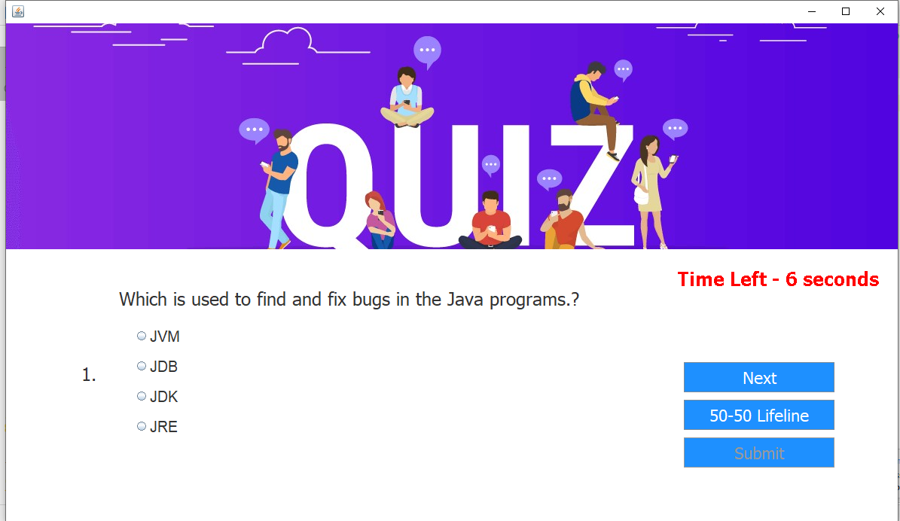

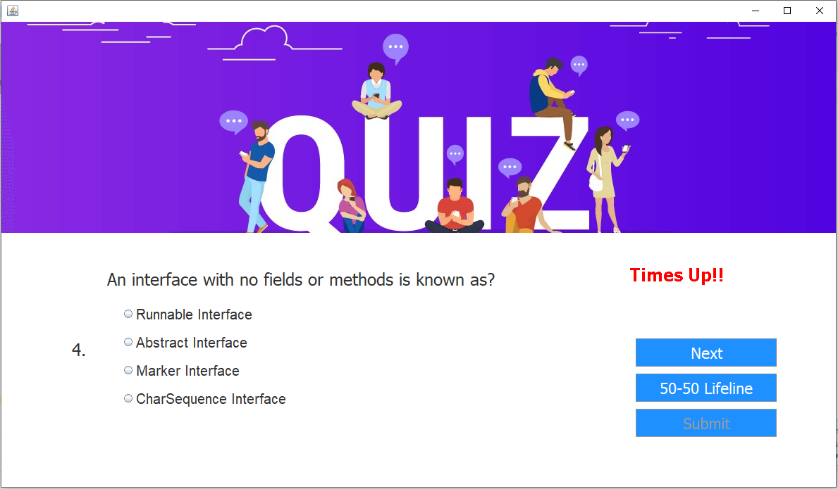

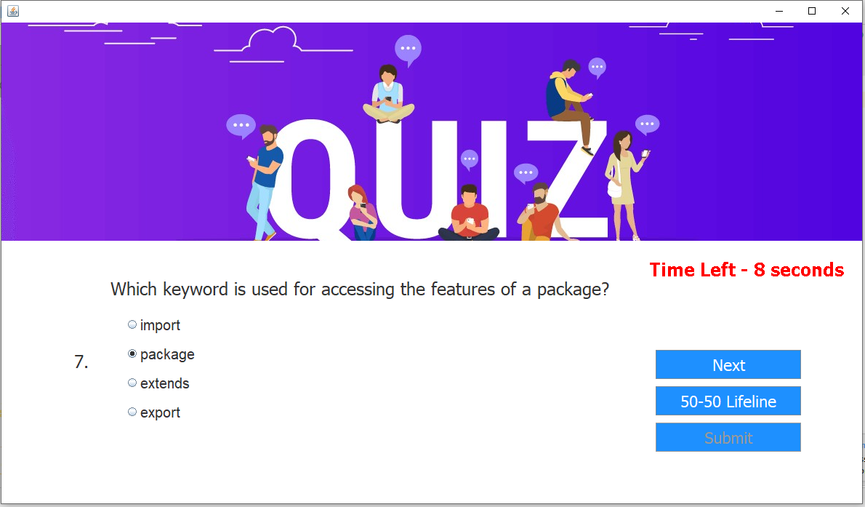

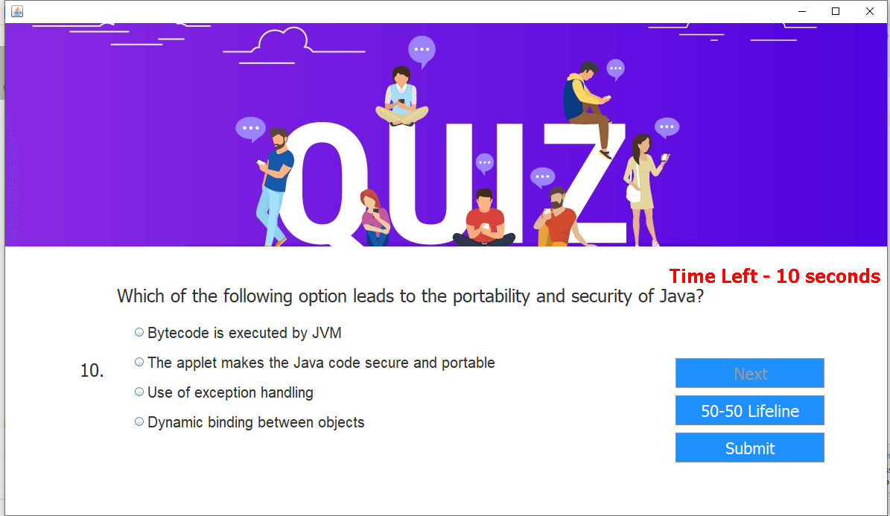

Score:

**package** simple.minds;

**import** javax.swing.*;

**import** java.awt.*;

**import** java.awt.event.*;

**public class** Score **extends** JFrame **implements** ActionListener{

Score(String username, **int** score){

setBounds(0, 0, 750, 550);

getContentPane().setBackground(Color.***WHITE***);

setLayout(**null**);

ImageIcon i1 = **new** ImageIcon(ClassLoader.*getSystemResource*(**"simple/minds/score.png"**));

Image i2 = i1.getImage().getScaledInstance(300, 250, Image.***SCALE_DEFAULT***);

ImageIcon i3 = **new** ImageIcon(i2);

JLabel l1 = **new** JLabel(i3);

l1.setBounds(0, 200, 300, 250);

add(l1);

JLabel l2 = **new** JLabel(**"Thankyou "** + username + **" for Playing Simple Minds"**);

l2.setBounds(45, 30, 700, 30);

l2.setFont(**new** Font(**"RALEWAY"**, Font.***PLAIN***, 26));

add(l2);

JLabel l3 = **new** JLabel(**"Your Score is "** + score);

l3.setBounds(350, 200, 300, 30);

l3.setFont(**new** Font(**"Jokerman"**, Font.***PLAIN***, 26));

l3.setForeground(**new** Color(199, 21, 133));

add(l3);

JButton b1 = **new** JButton(**"Play Again"**);

b1.setBackground(Color.***BLUE***);

b1.setForeground(Color.***WHITE***);

b1.addActionListener(**this**);

b1.setBounds(400, 270, 120, 30);

add(b1);

}

**public void** actionPerformed(ActionEvent ae){

**this**.setVisible(**false**);

setVisible(**true**);

}

**public static void** main(String[] args){

**new** Score(**""**, 0).setVisible(**true**);

}

}

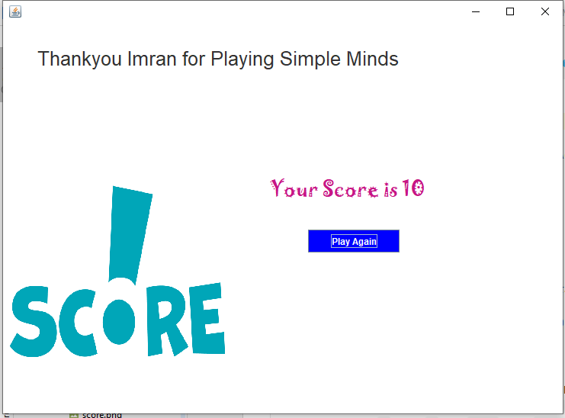

**That’s it!**

Docs:

Simple minds:

Code:

**package** simple.minds;  
**import** javax.swing.*;  
**import** java.awt.*;  
**import** java.awt.event.*;  
**public class** SimpleMinds **extends** JFrame **implements** ActionListener{  
 JButton **b1**, **b2**;  
 JTextField **t1**;  
 SimpleMinds(){  
 setBounds(0, 0, 1200, 500); *// dleft, //dup // length, height ///////* getContentPane().setBackground(Color.***WHITE***);  
 setLayout(**null**);  
  
 ImageIcon i1 = **new** ImageIcon(ClassLoader.*getSystemResource*(**"simple/minds/login.jpeg"**));  
 JLabel l1 = **new** JLabel(i1);  
 l1.setBounds(0, 0, 600, 500);  
 add(l1);  
  
 JLabel l2 = **new** JLabel(**"Simple Minds"**);  
 l2.setFont(**new** Font(**"Viner Hand ITC"**, Font.***BOLD***, 40));  
 l2.setForeground(**new** Color(30, 144, 254));  
 l2.setBounds(750, 60, 300, 45);  
 add(l2);  
  
 JLabel l3 = **new** JLabel(**"Enter Your Name"**);  
 l3.setFont(**new** Font(**"Mongolian Baiti"**, Font.***BOLD***, 18));  
 l3.setForeground(**new** Color(30, 144, 254));  
 l3.setBounds(810, 150, 300, 20);  
 add(l3);  
  
 **t1** = **new** JTextField();  
 **t1**.setBounds(735, 200, 300, 25);  
 **t1**.setFont(**new** Font(**"Times New Roman"**, Font.***BOLD***, 20));  
 add(**t1**);  
  
 **b1** = **new** JButton(**"Rules"**);  
 **b1**.setBounds(735, 270, 120, 25);  
 **b1**.setBackground(**new** Color(30, 144, 254));  
 **b1**.setForeground(Color.***WHITE***);  
 **b1**.addActionListener(**this**);  
 add(**b1**);  
  
 **b2** = **new** JButton(**"Exit"**);  
 **b2**.setBounds(915, 270, 120, 25);  
 **b2**.setBackground(**new** Color(30, 144, 254));  
 **b2**.setForeground(Color.***WHITE***);  
 **b2**.addActionListener(**this**);  
 add(**b2**);  
  
 setVisible(**true**);  
 }  
  
 **public void** actionPerformed(ActionEvent ae){  
 **if**(ae.getSource() == **b1**){  
 String name = **t1**.getText();  
 **this**.setVisible(**false**);  
 **new** Rules(name);  
 }**else**{  
 System.*exit*(0);  
 }  
 }  
  
 **public static void** main(String[] args) {  
 **new** SimpleMinds();  
 }  
}



Rules:

**package** simple.minds;

**import** javax.swing.*;

**import** java.awt.*;

**import** java.awt.event.*;

**public class** Rules **extends** JFrame **implements** ActionListener{

JButton **b1**, **b2**;

String **username**;

Rules(String username){

**this**.**username** = username;

setBounds(0, 0, 800, 650);

getContentPane().setBackground(Color.***WHITE***);

setLayout(**null**);

JLabel l1 = **new** JLabel(**"Welcome "** + username + **" to Simple Minds"**);

l1.setForeground(**new** Color(30, 144, 255));

l1.setFont(**new** Font(**"Viner Hand ITC"**, Font.***BOLD***, 28));

l1.setBounds(50, 20, 700, 30);

add(l1);

JLabel l2 = **new** JLabel(**""**);

l2.setFont(**new** Font(**"Tahoma"**, Font.***PLAIN***, 16));

l2.setBounds(20, 90, 600, 350);

l2.setText(

**"<html>"**+

**"1. You are trained to be a programmer and not a story teller, answer point to point"** + **"<br><br>"** +

**"2. Do not unnecessarily smile at the person sitting next to you, they may also not know the answer"** + **"<br><br>"** +

**"3. You may have lot of options in life but here all the questions are compulsory"** + **"<br><br>"** +

**"4. Crying is allowed but please do so quietly."** + **"<br><br>"** +

**"5. Only a fool asks and a wise answers (Be wise, not otherwise)"** + **"<br><br>"** +

**"6. Do not get nervous if your friend is answering more questions, may be he/she is doing Jai Mata Di"** + **"<br><br>"** +

**"7. Brace yourself, this paper is not for the faint hearted"** + **"<br><br>"** +

**"8. May you know more than what John Snow knows, Good Luck"** + **"<br><br>"** +

**"<html>"**

);

add(l2);

**b1** = **new** JButton(**"Back"**);

**b1**.setBounds(250, 500, 100, 30);

**b1**.setBackground(**new** Color(30, 144, 255));

**b1**.setForeground(Color.***WHITE***);

**b1**.addActionListener(**this**);

add(**b1**);

**b2** = **new** JButton(**"Start"**);

**b2**.setBounds(400, 500, 100, 30);

**b2**.setBackground(**new** Color(30, 144, 255));

**b2**.setForeground(Color.***WHITE***);

**b2**.addActionListener(**this**);

add(**b2**);

setVisible(**true**);

}

**public void** actionPerformed(ActionEvent ae){

**if**(ae.getSource() == **b1**){

**this**.setVisible(**false**);

**new** SimpleMinds().setVisible(**true**);

}**else if**(ae.getSource() == **b2**){

**this**.setVisible(**false**);

**new** Quiz(**username**).setVisible(**true**);

}

}

**public static void** main(String[] args){

**new** Rules(**""**);

}

}



Quiz:

**package** simple.minds;

**import** javax.swing.*;

**import** java.awt.*;

**import** java.awt.event.*;

**public class** Quiz **extends** JFrame **implements** ActionListener{

JButton **next**, **submit**, **lifeline**;

**public static int** *count* = 0;

**public static int** *timer* = 15;

**public static int** *ans_given* = 0;

**public static int** *score* = 0;

JLabel **qno**, **question**;

String **q**[][] = **new** String[10][5];

String **pa**[][] = **new** String[10][1];

String **qa**[][] = **new** String[10][2];

JRadioButton **opt1**, **opt2**, **opt3**, **opt4**;

ButtonGroup **options**;

String **username**;

Quiz(String username){

**this**.**username** = username;

setBounds(0, 0, 1200, 700);

getContentPane().setBackground(Color.***WHITE***);

setLayout(**null**);

ImageIcon i1 = **new** ImageIcon(ClassLoader.*getSystemResource*(**"simple/minds/quiz.jpg"**));

JLabel l1 = **new** JLabel(i1);

l1.setBounds(0, 0, 1200, 300);

add(l1);

**qno** = **new** JLabel(**""**);

**qno**.setFont(**new** Font(**"Tahoma"**, Font.***PLAIN***, 24));

**qno**.setBounds(100, 450, 50, 30);

add(**qno**);

**question** = **new** JLabel(**""**);

**question**.setFont(**new** Font(**"Tahoma"**, Font.***PLAIN***, 24));

**question**.setBounds(150, 350, 800, 30);

add(**question**);

**q**[0][0] = **"Which is used to find and fix bugs in the Java programs.?"**;

**q**[0][1] = **"JVM"**;

**q**[0][2] = **"JDB"**;

**q**[0][3] = **"JDK"**;

**q**[0][4] = **"JRE"**;

**q**[1][0] = **"What is the return type of the hashCode() method in the Object class?"**;

**q**[1][1] = **"int"**;

**q**[1][2] = **"Object"**;

**q**[1][3] = **"long"**;

**q**[1][4] = **"void"**;

**q**[2][0] = **"Which package contains the Random class?"**;

**q**[2][1] = **"java.util package"**;

**q**[2][2] = **"java.lang package"**;

**q**[2][3] = **"java.awt package"**;

**q**[2][4] = **"java.io package"**;

**q**[3][0] = **"An interface with no fields or methods is known as?"**;

**q**[3][1] = **"Runnable Interface"**;

**q**[3][2] = **"Abstract Interface"**;

**q**[3][3] = **"Marker Interface"**;

**q**[3][4] = **"CharSequence Interface"**;

**q**[4][0] = **"In which memory a String is stored, when we create a string using new operator?"**;

**q**[4][1] = **"Stack"**;

**q**[4][2] = **"String memory"**;

**q**[4][3] = **"Random storage space"**;

**q**[4][4] = **"Heap memory"**;

**q**[5][0] = **"Which of the following is a marker interface?"**;

**q**[5][1] = **"Runnable interface"**;

**q**[5][2] = **"Remote interface"**;

**q**[5][3] = **"Readable interface"**;

**q**[5][4] = **"Result interface"**;

**q**[6][0] = **"Which keyword is used for accessing the features of a package?"**;

**q**[6][1] = **"import"**;

**q**[6][2] = **"package"**;

**q**[6][3] = **"extends"**;

**q**[6][4] = **"export"**;

**q**[7][0] = **"In java, jar stands for?"**;

**q**[7][1] = **"Java Archive Runner"**;

**q**[7][2] = **"Java Archive"**;

**q**[7][3] = **"Java Application Resource"**;

**q**[7][4] = **"Java Application Runner"**;

**q**[8][0] = **"Which of the following is a mutable class in java?"**;

**q**[8][1] = **"java.lang.StringBuilder"**;

**q**[8][2] = **"java.lang.Short"**;

**q**[8][3] = **"java.lang.Byte"**;

**q**[8][4] = **"java.lang.String"**;

**q**[9][0] = **"Which of the following option leads to the portability and security of Java?"**;

**q**[9][1] = **"Bytecode is executed by JVM"**;

**q**[9][2] = **"The applet makes the Java code secure and portable"**;

**q**[9][3] = **"Use of exception handling"**;

**q**[9][4] = **"Dynamic binding between objects"**;

**qa**[0][1] = **"JDB"**;

**qa**[1][1] = **"int"**;

**qa**[2][1] = **"java.util package"**;

**qa**[3][1] = **"Marker Interface"**;

**qa**[4][1] = **"Heap memory"**;

**qa**[5][1] = **"Remote interface"**;

**qa**[6][1] = **"import"**;

**qa**[7][1] = **"Java Archive"**;

**qa**[8][1] = **"java.lang.StringBuilder"**;

**qa**[9][1] = **"Bytecode is executed by JVM"**;

**opt1** = **new** JRadioButton(**""**);

**opt1**.setBounds(170, 400, 700, 30);

**opt1**.setFont(**new** Font(**"Dialog"**, Font.***PLAIN***, 20));

**opt1**.setBackground(Color.***WHITE***);

add(**opt1**);

**opt2** = **new** JRadioButton(**""**);

**opt2**.setBounds(170, 440, 700, 30);

**opt2**.setFont(**new** Font(**"Dialog"**, Font.***PLAIN***, 20));

**opt2**.setBackground(Color.***WHITE***);

add(**opt2**);

**opt3** = **new** JRadioButton(**""**);

**opt3**.setBounds(170, 480, 700, 30);

**opt3**.setFont(**new** Font(**"Dialog"**, Font.***PLAIN***, 20));

**opt3**.setBackground(Color.***WHITE***);

add(**opt3**);

**opt4** = **new** JRadioButton(**""**);

**opt4**.setBounds(170, 520, 700, 30);

**opt4**.setFont(**new** Font(**"Dialog"**, Font.***PLAIN***, 20));

**opt4**.setBackground(Color.***WHITE***);

add(**opt4**);

**options** = **new** ButtonGroup();

**options**.add(**opt1**);

**options**.add(**opt2**);

**options**.add(**opt3**);

**options**.add(**opt4**);

**next** = **new** JButton(**"Next"**);

**next**.setFont(**new** Font(**"Tahoma"**, Font.***PLAIN***, 22));

**next**.setBackground(**new** Color(30, 144, 255));

**next**.setForeground(Color.***WHITE***);

**next**.addActionListener(**this**);

**next**.setBounds(900, 450, 200, 40);

add(**next**);

**lifeline** = **new** JButton(**"50-50 Lifeline"**);

**lifeline**.setFont(**new** Font(**"Tahoma"**, Font.***PLAIN***, 22));

**lifeline**.setBackground(**new** Color(30, 144, 255));

**lifeline**.setForeground(Color.***WHITE***);

**lifeline**.setBounds(900, 500, 200, 40);

**lifeline**.addActionListener(**this**);

add(**lifeline**);

**submit** = **new** JButton(**"Submit"**);

**submit**.setFont(**new** Font(**"Tahoma"**, Font.***PLAIN***, 22));

**submit**.setEnabled(**false**);

**submit**.setBackground(**new** Color(30, 144, 255));

**submit**.setForeground(Color.***WHITE***);

**submit**.addActionListener(**this**);

**submit**.setBounds(900, 550, 200, 40);

add(**submit**);

start(0);

}

**public void** actionPerformed(ActionEvent ae){

**if**(ae.getSource() == **next**){

repaint();

**opt1**.setEnabled(**true**);

**opt2**.setEnabled(**true**);

**opt3**.setEnabled(**true**);

**opt4**.setEnabled(**true**);

*ans_given* = 1;

**if**(**options**.getSelection() == **null**){

**pa**[*count*][0] = **""**;

}**else** {

**pa**[*count*][0] = **options**.getSelection().getActionCommand();

}

**if**(*count* == 8){

**next**.setEnabled(**false**);

**submit**.setEnabled(**true**);

}

*count*++;

start(*count*);

}**else if**(ae.getSource() == **submit**){

*ans_given* = 1;

**if**(**options**.getSelection() == **null**){

**pa**[*count*][0] = **""**;

}**else** {

**pa**[*count*][0] = **options**.getSelection().getActionCommand();

}

**for**(**int** i =0 ; i < **pa**.**length** ; i++){

**if**(**pa**[i][0].equals(**qa**[i][1])){

*score*+=10;

}**else**{

*score*+=0;

}

}

**this**.setVisible(**false**);

**new** Score(**username**, *score*).setVisible(**true**);

}**else if**(ae.getSource() == **lifeline**){

**if**(*count* == 2 || *count* == 4 || *count* == 6 || *count* == 8 || *count* == 9){

**opt2**.setEnabled(**false**);

**opt3**.setEnabled(**false**);

}**else** {

**opt1**.setEnabled(**false**);

**opt4**.setEnabled(**false**);

}

**lifeline**.setEnabled(**false**);

}

}

**public void** paint(Graphics g){

**super**.paint(g);

String time = **"Time Left - "** + *timer* + **" seconds"**; *// 15*

g.setColor(Color.***RED***);

g.setFont(**new** Font(**"Tahoma"**, Font.***BOLD***, 25));

**if**(*timer* > 0) {

g.drawString(time, 900, 380);

}**else** {

g.drawString(**"Times Up!!"**, 900, 400);

}

*timer*--; *// 14*

**try**{

Thread.*sleep*(1000);

repaint();

}**catch**(Exception e){

e.printStackTrace();

}

**if**(*ans_given* == 1){

*ans_given* = 0;

*timer* = 15;

}**else if**(*timer* < 0){

*timer* = 15;

**opt1**.setEnabled(**true**);

**opt2**.setEnabled(**true**);

**opt3**.setEnabled(**true**);

**opt4**.setEnabled(**true**);

**if**(*count* == 8){

**next**.setEnabled(**false**);

**submit**.setEnabled(**true**);

}

**if**(*count* == 9){

**if**(**options**.getSelection() == **null**){

**pa**[*count*][0] = **""**;

}**else** {

**pa**[*count*][0] = **options**.getSelection().getActionCommand();

}

**for**(**int** i =0 ; i < **pa**.**length** ; i++){

**if**(**pa**[i][0].equals(**qa**[i][1])){

*score*+=10;

}**else**{

*score*+=0;

}

}

**this**.setVisible(**false**);

**new** Score(**username**, *score*).setVisible(**true**);

}**else**{

**if**(**options**.getSelection() == **null**){

**pa**[*count*][0] = **""**;

}**else** {

**pa**[*count*][0] = **options**.getSelection().getActionCommand();

}

*count*++;

start(*count*);

}

}

}

**public void** start(**int** count){

**qno**.setText(**""** + (count + 1) + **". "**);

**question**.setText(**q**[count][0]);

**opt1**.setLabel(**q**[count][1]);

**opt1**.setActionCommand(**q**[count][1]);

**opt2**.setLabel(**q**[count][2]);

**opt2**.setActionCommand(**q**[count][2]);

**opt3**.setLabel(**q**[count][3]);

**opt3**.setActionCommand(**q**[count][3]);

**opt4**.setLabel(**q**[count][4]);

**opt4**.setActionCommand(**q**[count][4]);

**options**.clearSelection();

}

**public static void** main(String[] args){

**new** Quiz(**""**).setVisible(**true**);

}

}









Score:

**package** simple.minds;

**import** javax.swing.*;

**import** java.awt.*;

**import** java.awt.event.*;

**public class** Score **extends** JFrame **implements** ActionListener{

Score(String username, **int** score){

setBounds(0, 0, 750, 550);

getContentPane().setBackground(Color.***WHITE***);

setLayout(**null**);

ImageIcon i1 = **new** ImageIcon(ClassLoader.*getSystemResource*(**"simple/minds/score.png"**));

Image i2 = i1.getImage().getScaledInstance(300, 250, Image.***SCALE_DEFAULT***);

ImageIcon i3 = **new** ImageIcon(i2);

JLabel l1 = **new** JLabel(i3);

l1.setBounds(0, 200, 300, 250);

add(l1);

JLabel l2 = **new** JLabel(**"Thankyou "** + username + **" for Playing Simple Minds"**);

l2.setBounds(45, 30, 700, 30);

l2.setFont(**new** Font(**"RALEWAY"**, Font.***PLAIN***, 26));

add(l2);

JLabel l3 = **new** JLabel(**"Your Score is "** + score);

l3.setBounds(350, 200, 300, 30);

l3.setFont(**new** Font(**"Jokerman"**, Font.***PLAIN***, 26));

l3.setForeground(**new** Color(199, 21, 133));

add(l3);

JButton b1 = **new** JButton(**"Play Again"**);

b1.setBackground(Color.***BLUE***);

b1.setForeground(Color.***WHITE***);

b1.addActionListener(**this**);

b1.setBounds(400, 270, 120, 30);

add(b1);

}

**public void** actionPerformed(ActionEvent ae){

**this**.setVisible(**false**);

setVisible(**true**);

}

**public static void** main(String[] args){

**new** Score(**""**, 0).setVisible(**true**);

}

}



**That’s it!**

ss